

Experiment No.4

Title: Execution of Spatial database queries

Page No:

Batch:B2 Roll No.:1914078 Experiment No.:4

Aim: To execute spatial queries using PostGIS. ___________________________________________________________________________

Resources needed: PostgreSQL 9.6, PostGIS 2.0 ___________________________________________________________________________

Theory

PostGIS is an open source software program that adds support for geographic objects to the PostgreSQL object-relational database. PostGIS follows the Simple Features for SQL specification from the Open Geospatial Consortium (OGC). PostGIS turns the PostgreSQL Database Management System into a spatial database by adding support for the three features: spatial types, indexes, and functions. Because it is built on PostgreSQL, PostGIS automatically inherits important “enterprise” features as well as open standards for implementation. PostgreSQL is a powerful, object-relational database management system (ORDBMS). It is also open source software.

Features of PostGIS

- Geometry types for points, line strings, polygons, multi-points, multi-line-strings, multi-polygons and geometry collections.

- Spatial predicates for determining the interactions of geometries using the 3x3 Egenhofer matrix (provided by the GEOS software library).

- Spatial operators for determining geospatial measurements like area, distance, length and perimeter.

- Spatial operators for determining geospatial set operations, like union, difference,

symmetric difference and buffers (provided by GEOS).

- R-tree-over-GiST (Generalised Search Tree) spatial indexes for high speed spatial querying.

- Index selectivity support, to provide high performance query plans for mixed spatial/non-spatial queries.

- For raster data

__________________________________________________________________________

Procedure:

1. Installation of relational database PostgreSQL 9.6 (download from http://www.enterprisedb.com/products-services-training/pgdownload )
- Installation of PostGIS using Application stack builder.

- Create spatial database.

- Execute the spatial queries on given data to perform following task. (Refer http://www.postgis.org/docs/reference.html)

  - Find the rivers crossing 'United States'.
II. List the countries with the area covered by water body

- Find cities belong to Canada
5. Execute a KNN query to get K neighbours of the given points.
6 Execute any one range query

“KNN” stands for “K nearest neighbours”, where “K” is the number of neighbours you are looking for. KNN is a pure index based nearest neighbour search. ... The KNNsystem works by evaluating distances between bounding boxes inside the PostGISR-Tree index.

SELECT ST_Distance(geom, 'SRID=3005;POINT(1011102 450541)'::geometry) as d,edabbr, vaabbr
FROM va2005
ORDER BY d limit 10;

d | edabbr | vaabbr
------------------+--------+--------
0 | ALQ | 128
5541.57712511724 | ALQ | 129A
5579.67450712005 | ALQ | 001
6083.4207708641 | ALQ | 131
7691.2205404848 | ALQ | 003
7900.75451037313 | ALQ | 122
8694.20710669982 | ALQ | 129B
9564.24289057111 | ALQ | 130
12089.665931705 | ALQ | 127
18472.5531479404 | ALQ | 002
(10 rows)
Range query in Postgis
SELECT ST_Reclass(rast, 1,
'[0-90]:0,(90-100):1,[100-1000):2',
'4BUI', 0) AS rast FROM sometable
WHERE filename = '123.tif'; ________________________________________________________________________

Page No:

Results: (Program printout with output)
Running given script;
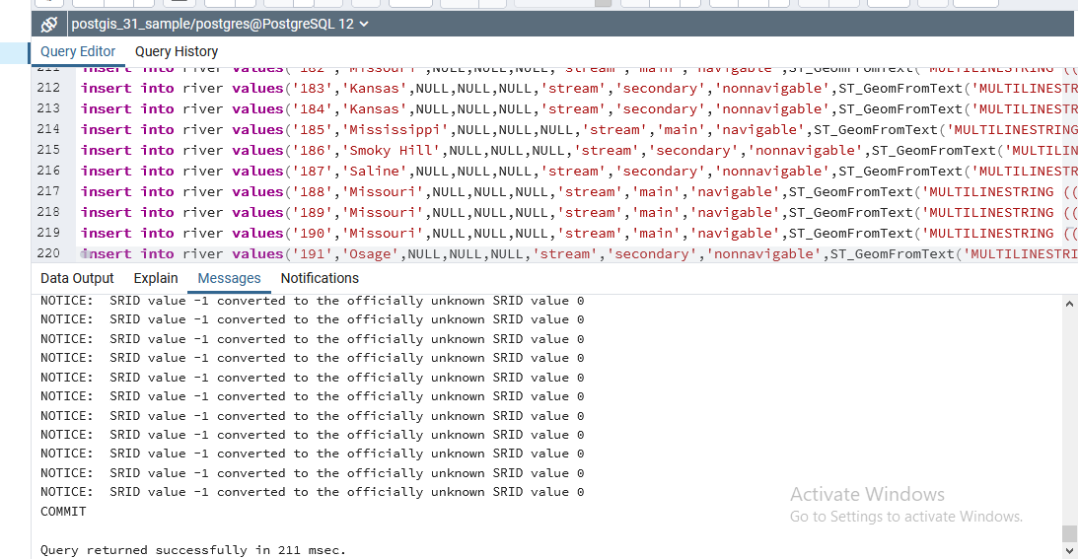

Q) Find the rivers crossing 'United States'.
Ans) select river.gid,river.name,country.cntry_name
From river,country
where
((ST_Crosses(river.the_geom, country.the_geom )) AND
country.cntry_name= 'United States') ;
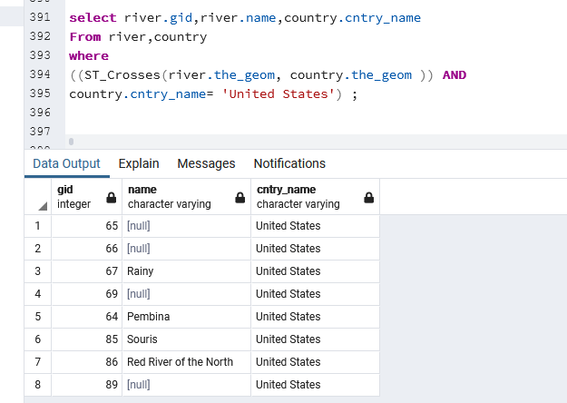
Q.2) List the countries with the area covered by water body
Ans: select distinct country.cntry_name,water.name
from country, water
where
(ST_Within(water.the_geom,country.the_geom) );
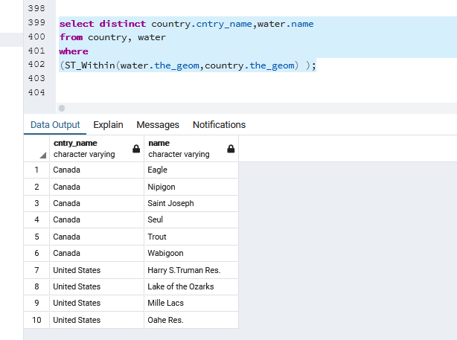
Find cities belong to Canada
Ans) select city.city_name,country.cntry_name
from city,country
where((ST_CoveredBy(city.the_geom,country.the_geom))
AND
country.cntry_name='Canada');
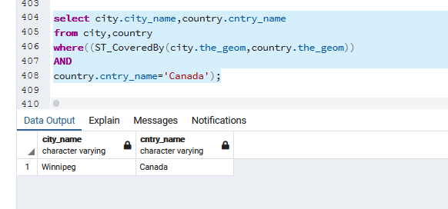

Step 5:
KNN query
Q) Selecting water gid, name, city admin_name and gid for top 10 waters nearest to city Bismarck
SELECT water.gid as water_gid, water.name as water_name, city.gid as city_gid,
city.admin_name, ST_Distance(water.the_geom, city.the_geom) as distance
FROM water, city
WHERE city.city_name = 'Bismarck'
ORDER BY ST_Distance(water.the_geom, city.the_geom) ASC
LIMIT 10;
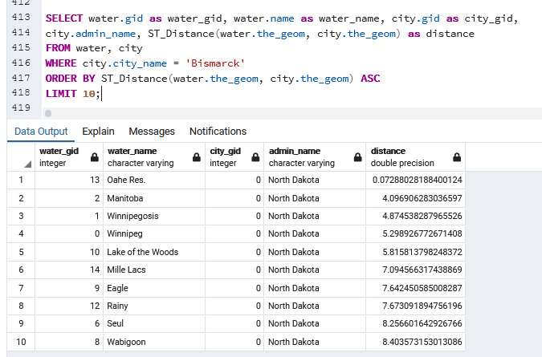

Range query:
Selecting city geom and name and water geom and distance to find all waters within range of 20 from city Bismarck
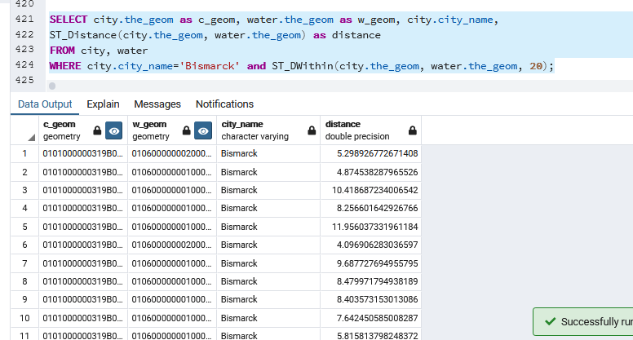

___________________________________________________________________________
Questions:
1. Explain the spatial functions used for these queries in detail.

ST_Distance
Calculates the shortest distance between two spatial objects. For GEOMETRY objects, the distance is measured in Cartesian coordinate units. For GEOGRAPHY objects, the distance is measured in meters.
ST_CoveredBy
ST_CoveredBy returns true if the first input geometry is covered by the second input geometry. Geometry A is covered by geometry B if both are nonempty and every point in A is a point in B.

ST_Within
If spatial object g1 is completely inside of spatial object g2, then ST_Within returns true. Both parameters must be the same spatial data type. Either specify two GEOMETRY objects or two GEOGRAPHY objects.
If an object such as a point or linestring only exists along a polygon's boundary, then ST_Within returns false. The interior of a linestring is all the points along the linestring except the start and end points.

ST_Crosses
Determines if one GEOMETRY object spatially crosses another GEOMETRY object. If two objects touch only at a border, ST_Crosses returns FALSE.
Two objects spatially cross when both of the following are true:
- The two objects have some, but not all, interior points in common.
- The dimension of the result of their intersection is less than the maximum dimension of the two objects.

Outcomes:

Design advanced database systems using Object relational, spatial, NOSQL Databases and its implementaition

Conclusion: (Conclusion to be based on outcomes achieved)

Executed several spatial queries on a spatial database using PostGis
Grade: AA / AB / BB / BC / CC / CD /DD

Signature of faculty in-charge with date
___________________________________________________________________________
References:

- Elmasri and Navathe, “Fundamentals of Database Systems”, Pearson Education

- Raghu Ramakrishnan and Johannes Gehrke, “Database Management Systems” 3rd
Edition, McGraw Hill,2002
- Korth, Silberchatz, Sudarshan, “Database System Concepts” McGraw Hill

- http://www.bostongis.com/PrinterFriendly.aspx?content_name=postgis_tut01

